Assignment 3
Auto Analytical Report
In this analysis, we are interested in reporting the fuel efficiency of the auto (which is measured by the recorded miles per gallon) based on a set of available independent variables. The Auto1.csv dataset contains the detailed information of 392 vehicles.

Initial diagnostic analysis revealed violations of linear regression assumptions, which includes linearity, zero mean, constant variance, and normality. Therefore, few of approaches are considered to correct these issues.

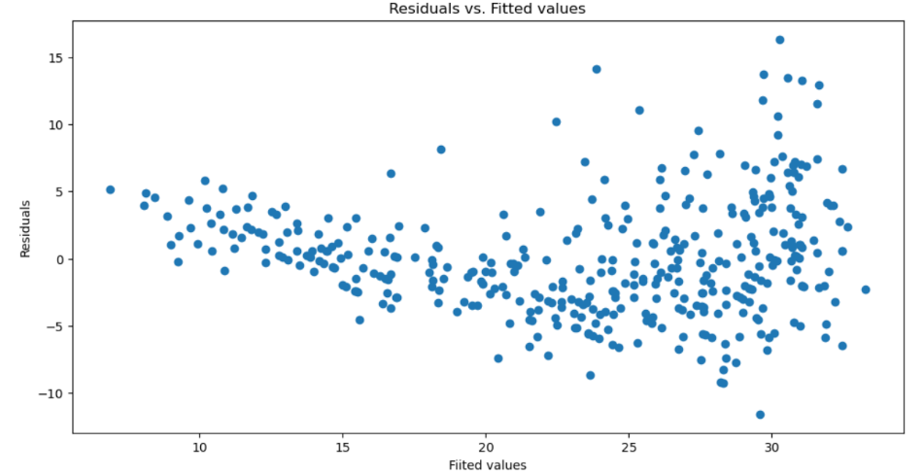
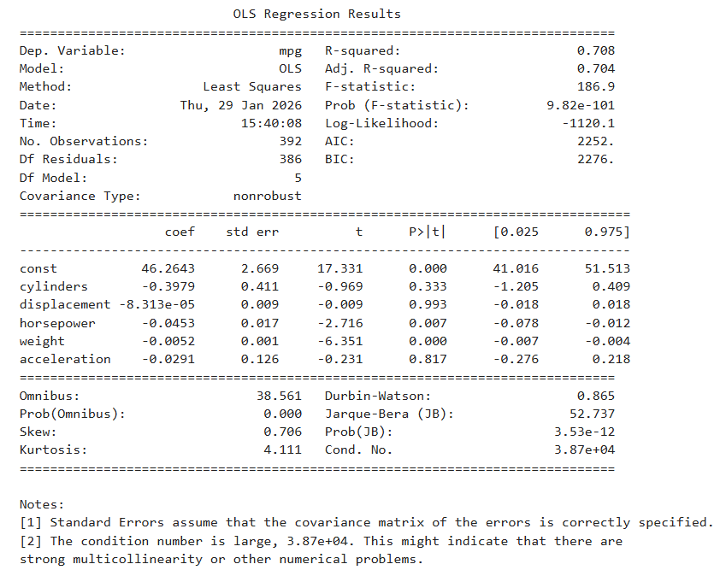
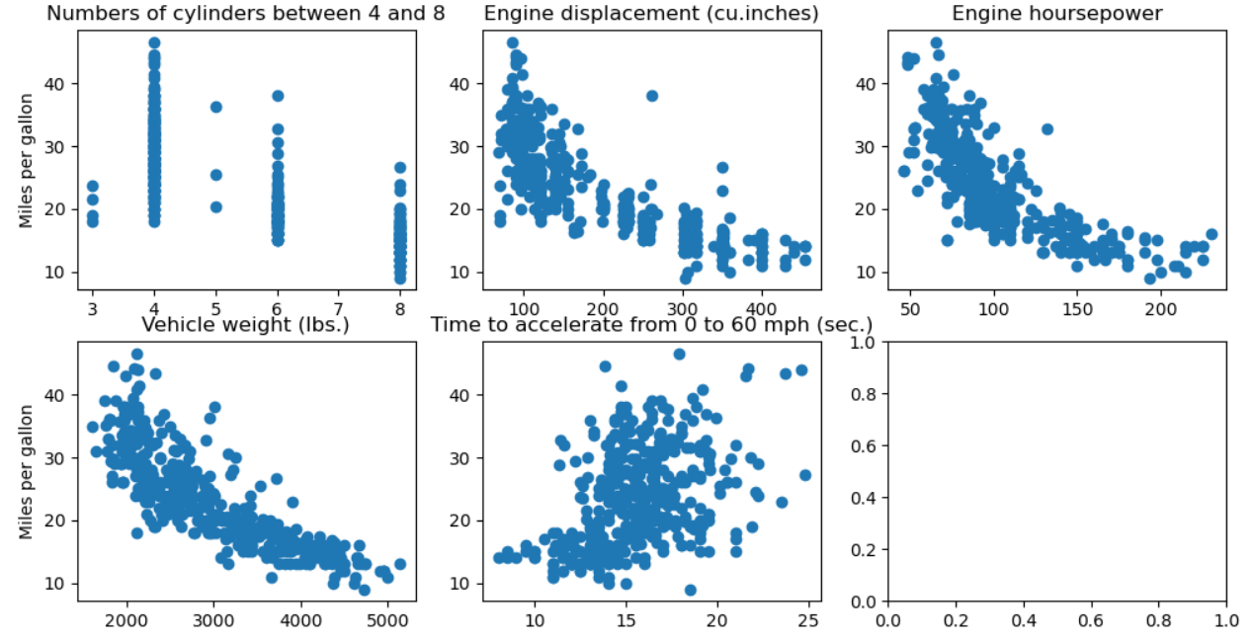
The reports below are the original OLS results and diagnostic checking.

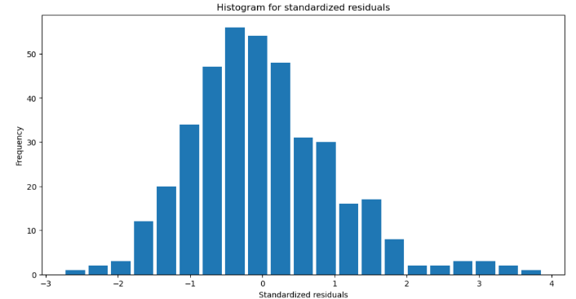
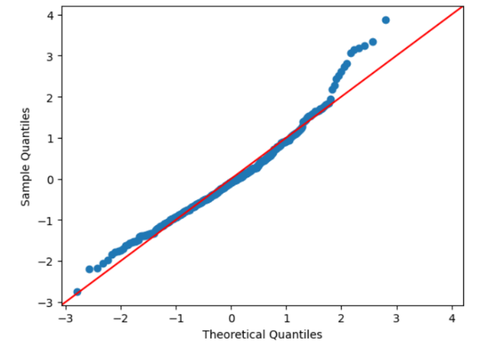
- The plot pattern of residual plot is slightly U-shaped, indicating the potential of zero mean.
- The variance of residuals increases as the fitted response value increases, indicating the potential violation of constant variance.
- The points for Q-Q plot does not fall on a straight line. Instead, there is a heavy tail to the positive side, which indicates the violation of normality assumption.
- The histogram plot is slightly skewed to the right, indicating there is potential violation of the normality assumption.
1. To fix the violation of zero mean assumption, we first consider the polynomial regression. Specifically, please try adding a square term for those predictors which exhibit nonlinear relationship with the response (model 1). Report the fitted model, the R-square, and comment on the significance of the predictors. Based on this model, redo the diagnostic checking.
Step 1: Adding square term for those predictors which exhibit nonlinear relationship with the response
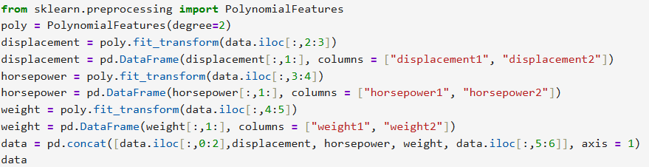
Step 2: Fit a multivariate linear regression model with all predictors using OLS function from statsmodels, and report the results.
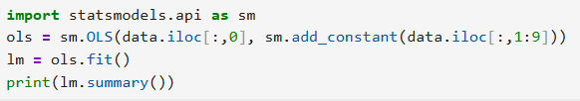
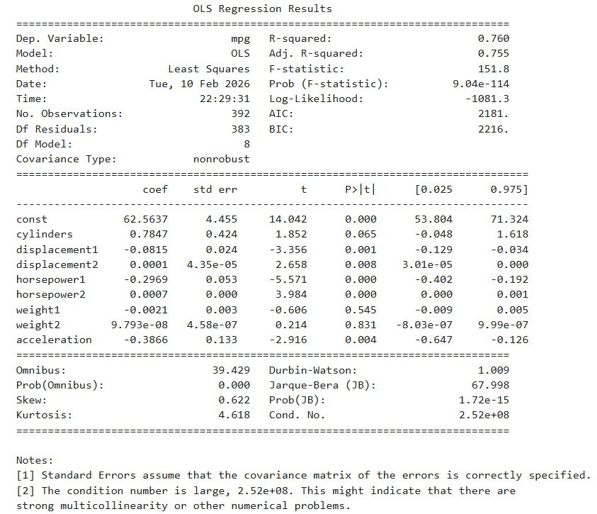
As shown on the summery table above, the model 1 fitted linear regression is:
mpg = 62.5637 + 0.7847cylinders – 0.0815displacement1 + 0.0001displacement2 – 0.2969horsepower1 + 0.0007horsepower2 – 0.0021weight1 + 9.793* 10⁻⁸ weight2 – 0.3866acceleration
The R² of the model increases from 0.708 to 0.760, indicating that the model explains the variation slightly better.
The squared term for displacement (displacement2) and horsepower (horsepower2) are significant, as both are less than 0.05, indicating that they are help to explain the miles per gallon response. Meanwhile, the cylinders, weight1 and weight2 are not significant in explaining the response value since their p-value are greater than 0.05.
Step 3: Redo the diagnostic test
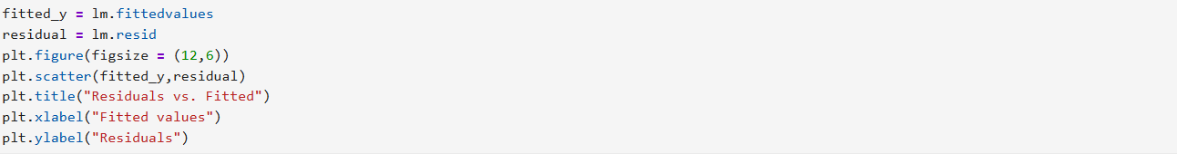
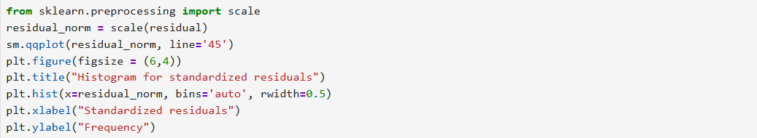
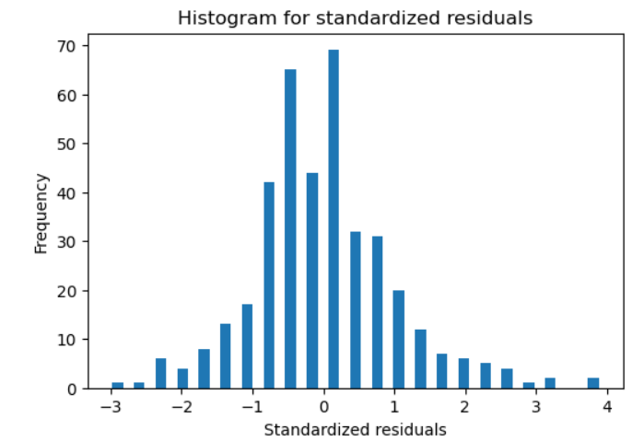
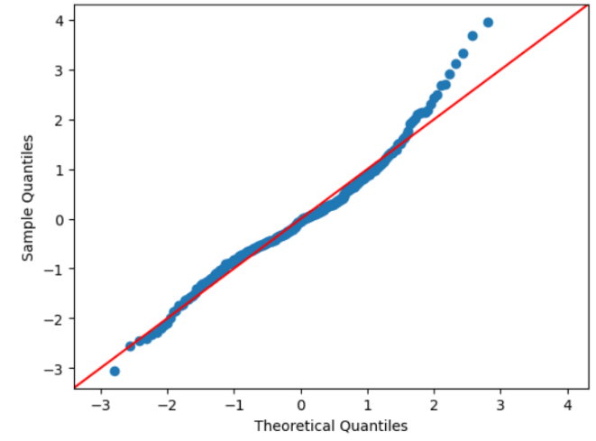
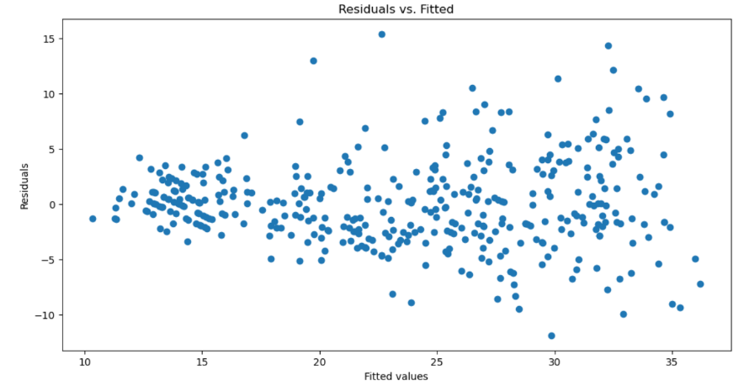
- The residual plot seems to be improved and it mostly satisfies the zero mean assumption.
- As the fitted values increases, the variance of residuals slightly increases, indicating that there is a chance of violating the constant variance assumption.
- The Q-Q plot shows that the residuals has some values that are not close to the 45-degree reference line. Thus, the histogram show the right skewness. Therefore, both of Q-Q plot and the histogram suggests there is still violation in normality assumption, indicating the squared term transformation is not improving the data normality.

2. We can also try to fix the violation of zero mean assumption by considering the nonlinear transformation of those predictors which exhibit nonlinear relationship with the response (model 2). Specify the transformation that you are going to use, construct scatter plots of response variable versus each of the transformed predictors, and make the comments. Then report the new model, the R-square, and comment on the significance of the predictors. Based on this model, redo the diagnostic checking.
Step 1: Import the data again to set it as original data
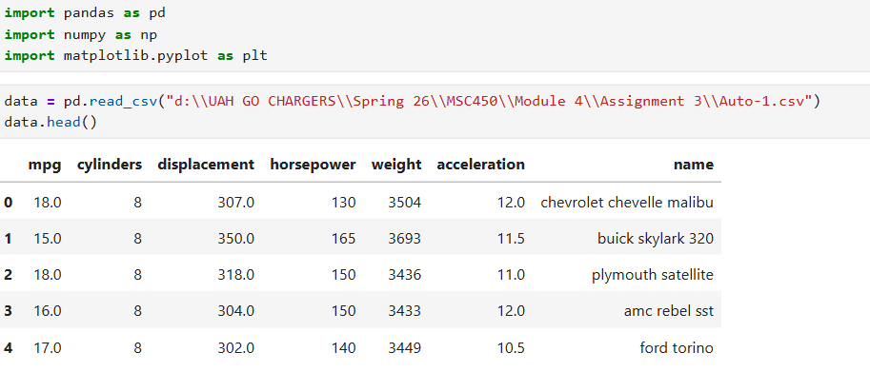
Step 2: The scatter plots of mpg vs. displacement, mpg vs. horsepower, mpg vs. weight are showing the decrease nonlinear trend. Thus, applying log transformation into displacement, horsepower and weight can result in a more linear pattern. Therefore, log() pattern is used in model 2
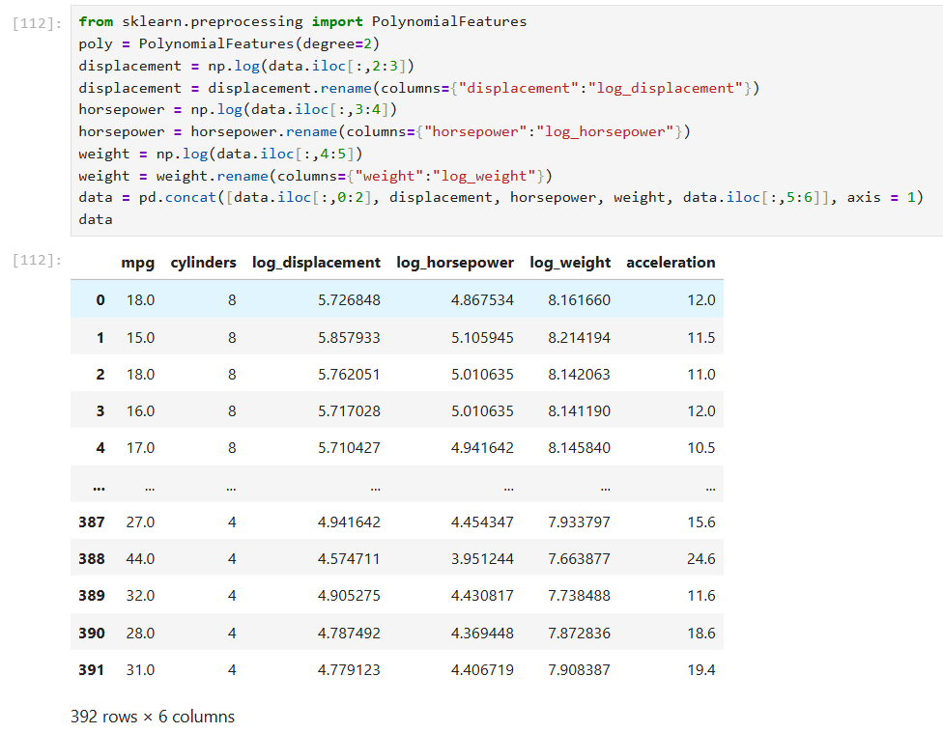

Step 3: Construct scatter plots of response variable versus each of the transformed predictors
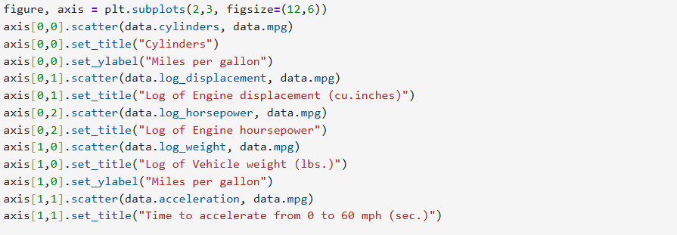
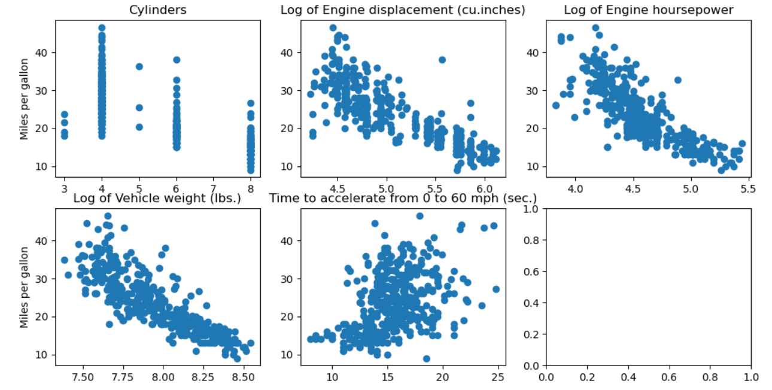
After the transformation, the plots of mpg versus log_displacement, log_horsepower, log_weight appear to have more linear relationship.
Step 4: Fit a multivariate linear regression model with all predictors using OLS function from statsmodels, and report the results.
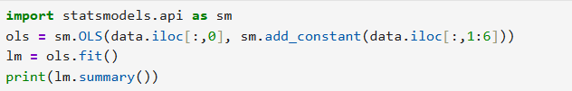
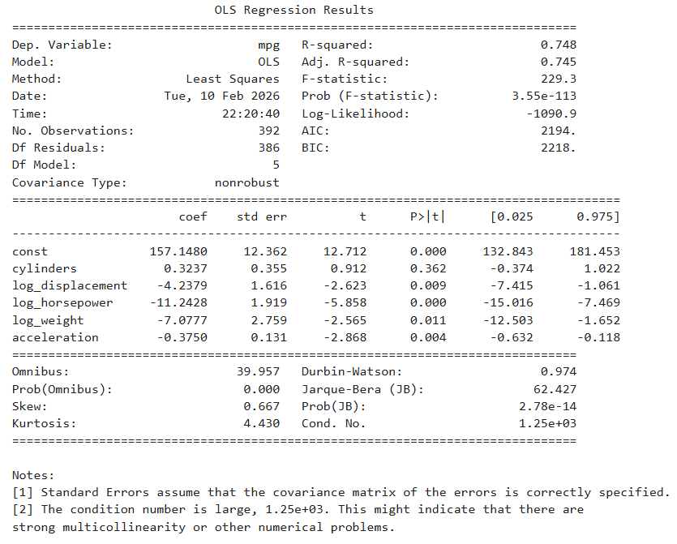
As shown in the OLS results, the model 2 fitted linear regression is:
mpg = 157.1480 + 0.3237cylinders – 4.2379log_displacement – 11.2428log_horsepower – 7.0777log_weight – 0.3750acceleration.
The R² result slightly increase from 0.708 to 0.748, indicating that the model regression explains the variation slightly better.
As we noticed, the log_displacement, log_horsepower, log_weight, and acceleration are all significant predictors in explaining the response value mpg since their p-values are less than 0.05. However, the cylinders data is not significant in the variance explanation of the regressions because its p-value is greater than 0.05.
Step 5: Redo the diagnostic check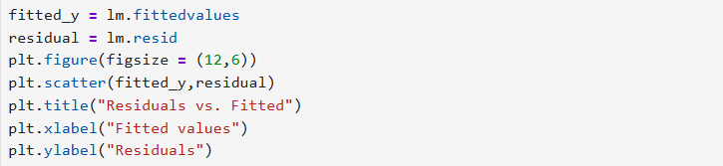
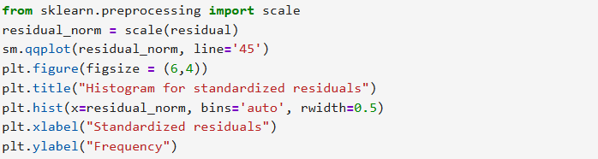
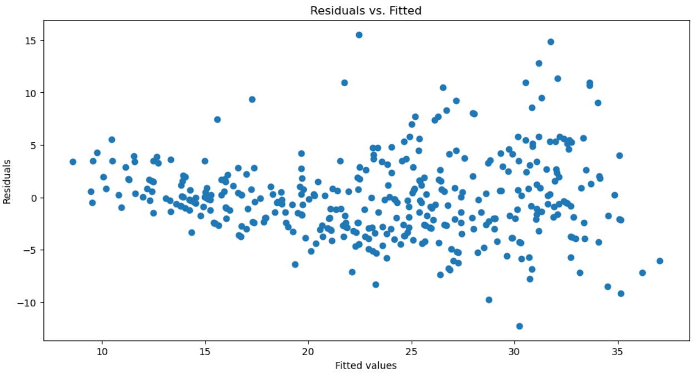
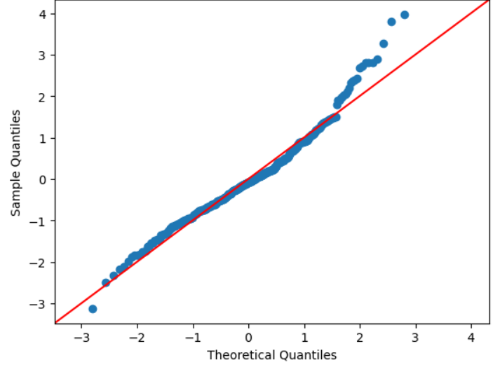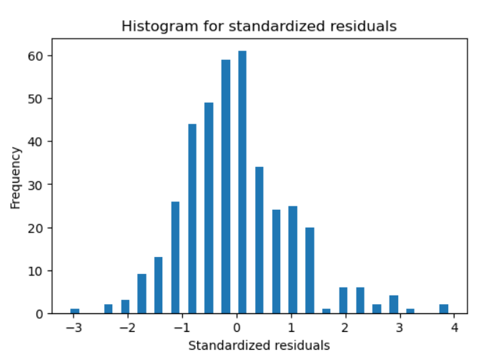
- The residual plot seems to be improved and it mostly satisfies the zero mean assumption.
- As the fitted values increases, the variance of residuals slightly increases, indicating that there is a chance of violating the constant variance assumption.
- The Q-Q plot shows that the residuals has some values that are not close to the 45-degree reference line. Thus, the histogram show the right skewness. Therefore, both of Q-Q plot and the histogram suggests there is still violation in normality assumption, indicating the log transformation is not improving the data normality.

3. Next, we focus on the violation of constant variance and normality. According to the diagnostic check results that we reported in assignment 2, the variance of residuals increases as the fitted response values increases, and the residual distribution is right skewed. Thus, we first consider a log-transformation of the response variable and regress it on the original predictors (without being transformed) (model 3). Report the fitted model, the R-square, and comment on the significance of the predictors. Also, please interpret the coefficients for horsepower. Based on this model, redo the diagnostic checking.
Step 1: Import the data again to set it as original data
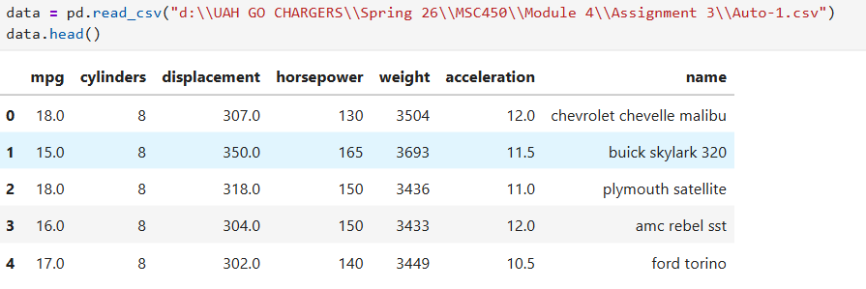
Step 2: Use the log transformation on response variable
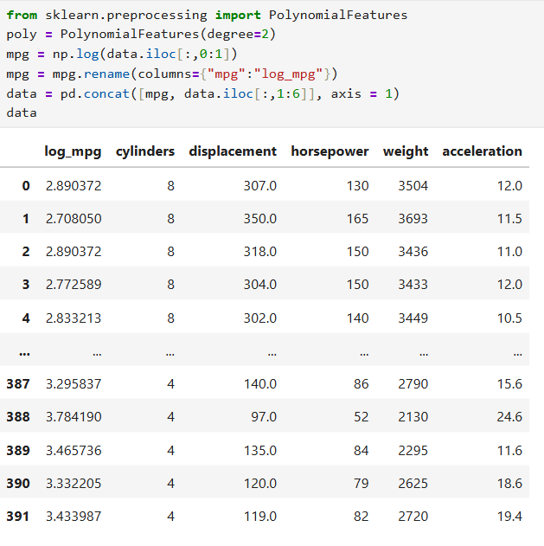
Step 3: Fit a multivariate linear regression model with all predictors using OLS function from statsmodels, and report the results.
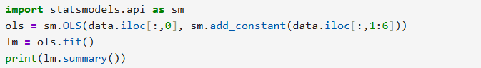
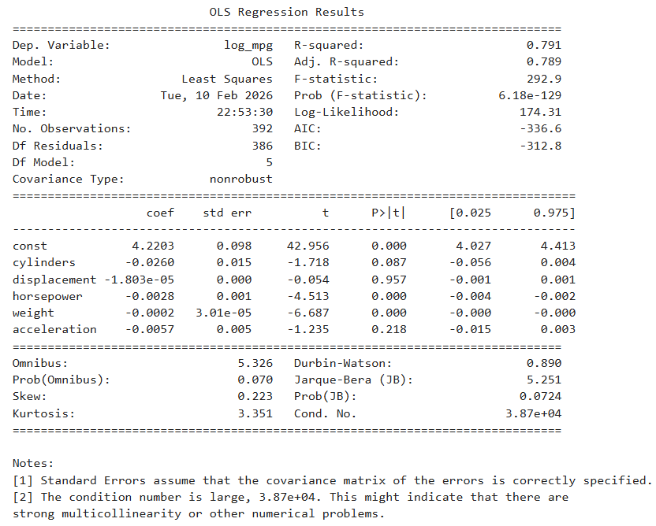
As the OLS results shown above, the model 3 fitted regression is:
log_mpg = 4.2203 – 0.026cylinders – 1.803 * 10⁻⁵ displacement – 0.0028horsepower – 0.0002weight – 0.0057acceleration
The R² result slightly increase from 0.708 to 0.791, indicating that the model regression explains the variation slightly better.
Based on the results, the horsepower and weight predictors are all significant in explaining the response value mpg since their p-values are less than 0.05. However, the cylinders, displacement, and acceleration predictors are not significant in the variance explanation of the regressions because their p-value are greater than 0.05.
Step 4: Interpret the coefficients of the horsepower
Every increase unit in horsepower is associated with approximately a 0.28% decrease in mpg.
Step 5: Redo the diagnostic check
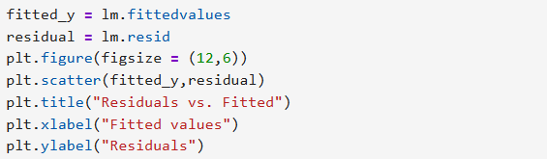
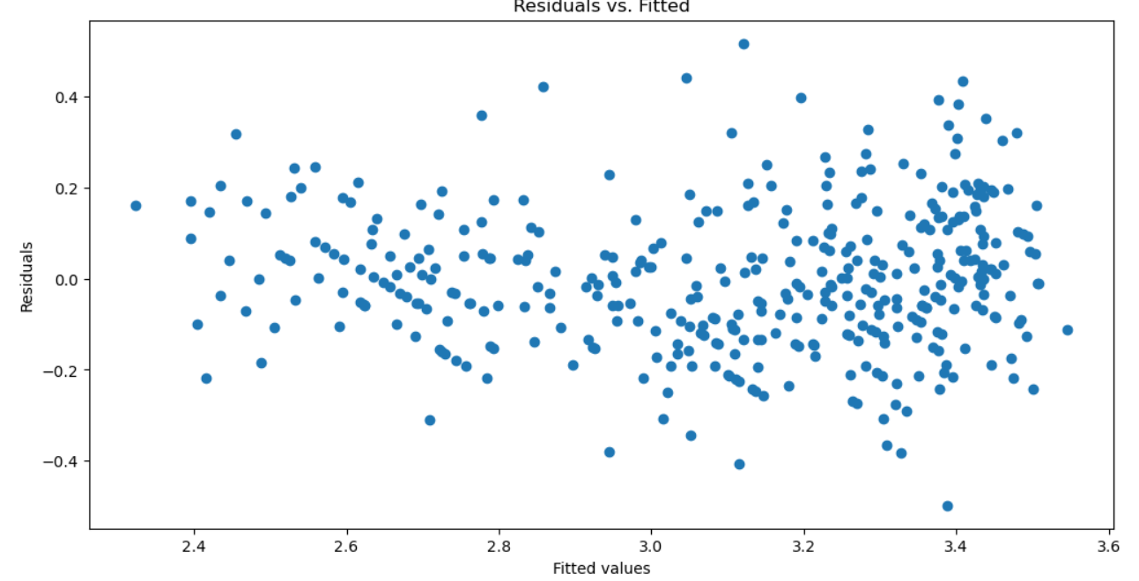
- In residual plot, the zero mean assumption is mostly satisfied since the data scatters slightly even around 0. Thus, the constant variance assumption seems to be satisfied as fitted values increase, the variance of residuals stays constant.

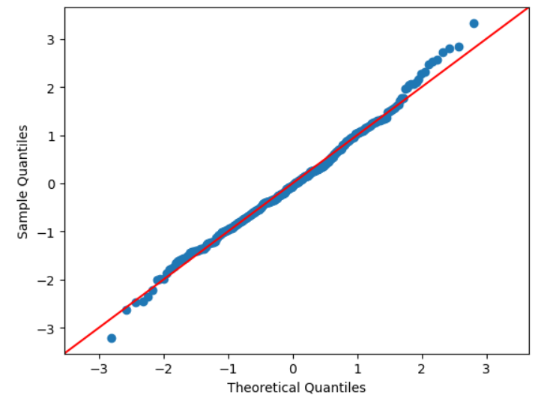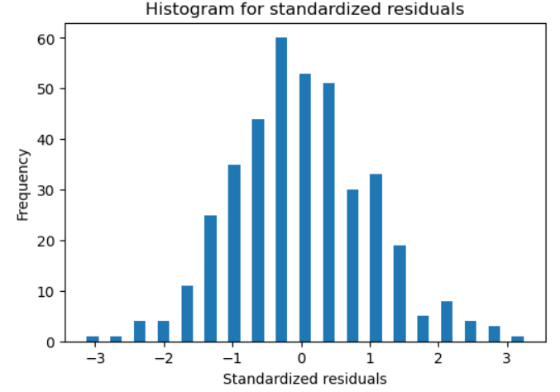
- The Q-Q plot shows that the residuals has most of the values close to the 45-degree reference line. Thus, the histogram shows the symmetric compared to the previous models. Therefore, both of Q-Q plot and the histogram suggests there is still slight deviation at the tails, the distribution appears approximately normal, indicating the log of response value improves the normality assumption.

4. Let’s now regress the log-transformed response variable on the transformed predictors that we used in model 2 (model 4). Report the fitted model, the R-square, and comment on the significance of the predictors. Based on this model, redo the diagnostic checking.
Step 1: Import the data again to set it as original data
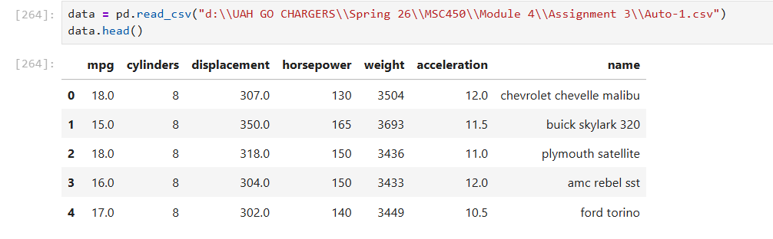
Step 2: Use the log transformation on response variable on the transformed predictors that we used in model 2.
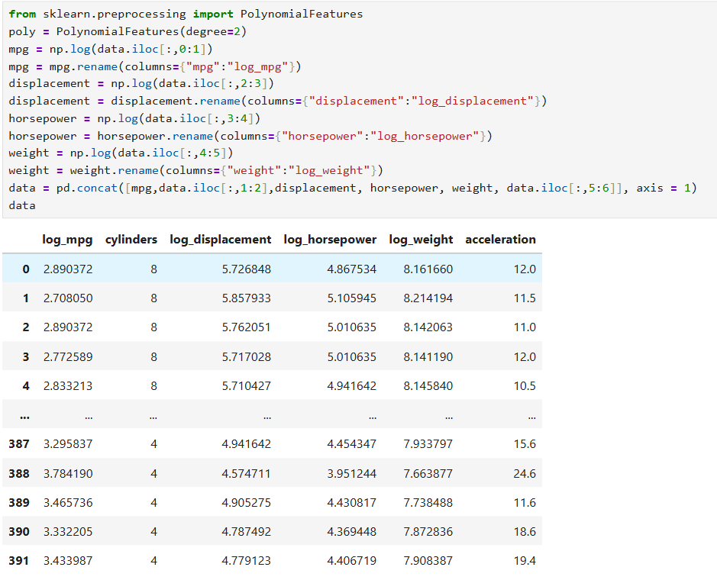
Step 3: Fit a multivariate linear regression model with all predictors using OLS function from statsmodels, and report the results.
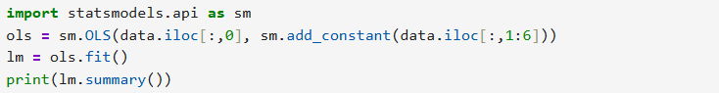
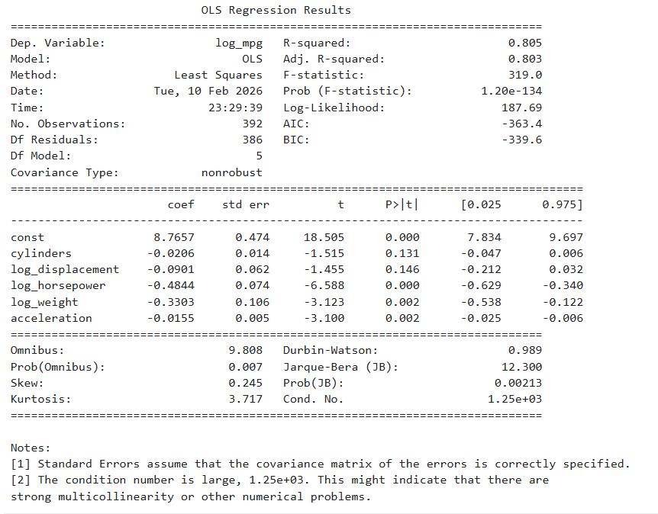
As the OLS results shown above, the model 4 fitted regression is:
log_mpg = 8.7657 – 0.0206cylinders – 0.0901log_displacement – 0.4844log_horsepower – 0.3303log_weight – 0.0155acceleration
The R² result significantly increase from 0.708 to 0.805, indicating that the model regression explains the variation better.
Based on the results, the log_hoursepower, log_weight and acceleration predictors are all significant in explaining the response value mpg since their p-values are less than 0.05. However, the cylinders and log_displacement predictors are not significant in the variance explanation of the regressions because their p-value are greater than 0.05.
Step 4: Redo the diagnostic check
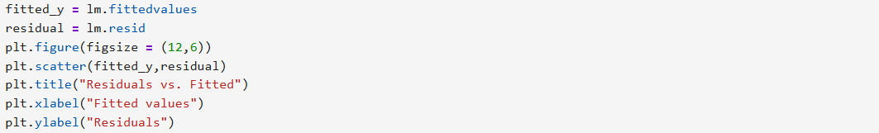
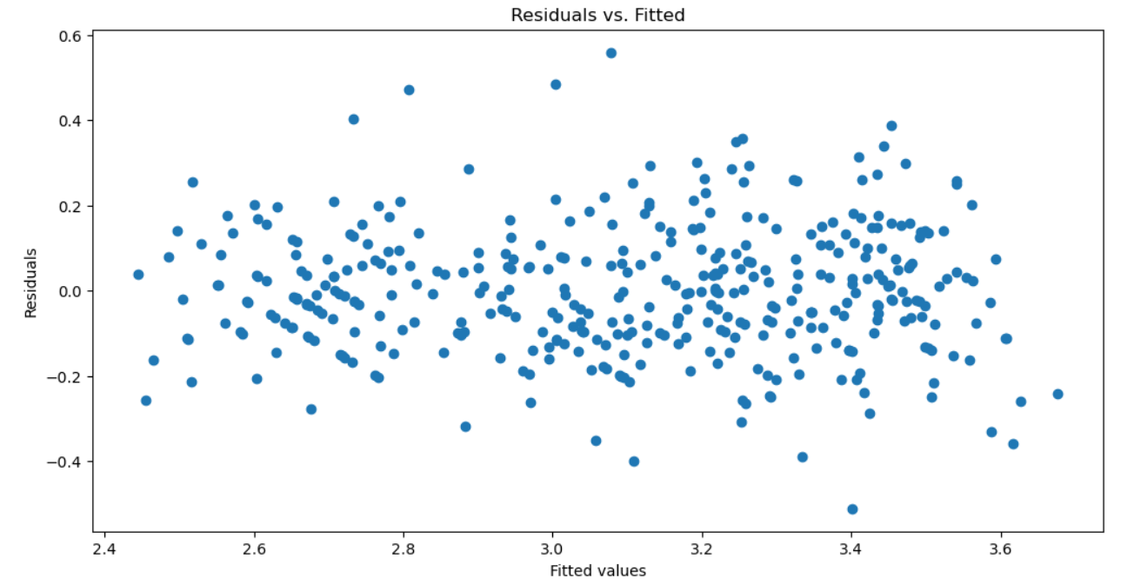
- In residual plot, the zero mean assumption is mostly satisfied since the data scatters randomly with even values for each side of 0. Thus, the constant variance assumption seems to be satisfied as fitted values increase, the variance of residuals stays constant.
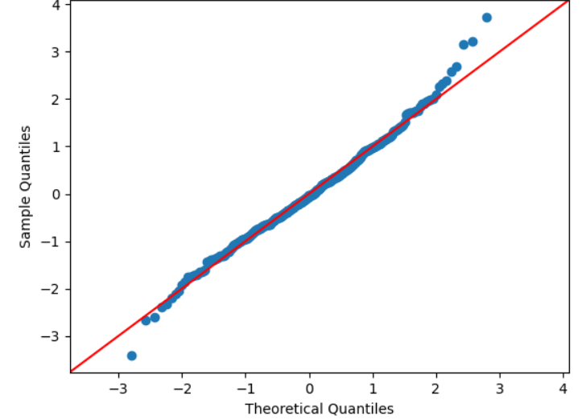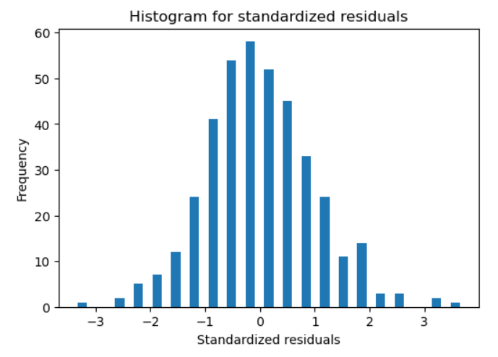
- The Q-Q plot shows that the residuals has most of the values close to the 45-degree reference line. Thus, the histogram shows the symmetric compared to the previous models. Therefore, both of Q-Q plot and the histogram suggests there is still slight deviation at the tails, the distribution appears approximately normal.
5. (Bonus question) Based on model 4, please interpret the coefficients for horsepower.
For every percentage increase of the horsepower, it will cause to 0.4844% decrease in mpg.

6. Finally, let’s try the Box-Cox transformation. Please transform the response variable using the optimal lambda value with the highest log-likelihood and regress it on the transformed predictors that we used in model 2 & 4 (model 5). Report the fitted model, the R-square, and comment on the significance of the predictors. Based on this model, redo the diagnostic checking.
Step 1: Import the data again to set it as original data
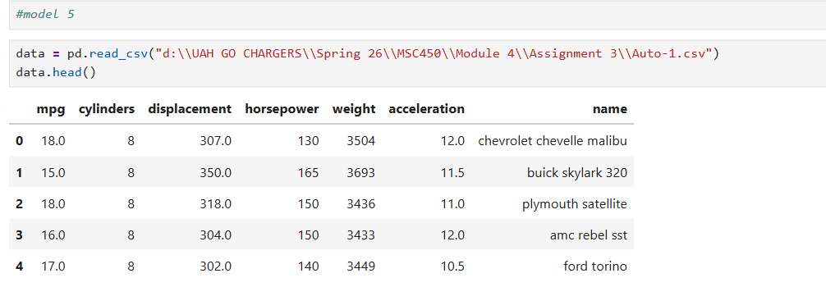
Step 2: Use log transformation for same predictors in model 2
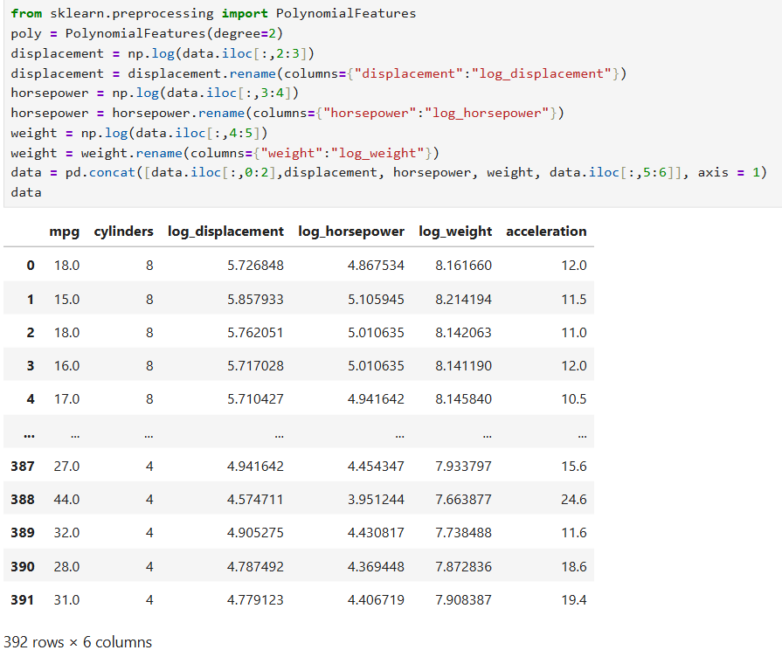
Step 3: Using Box-Cox to determine log-likelihood of the response value
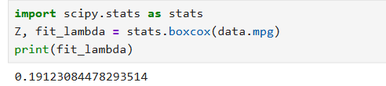
Step 4: Fit a multivariate linear regression model with all predictors using OLS function from statsmodels, and report the results.
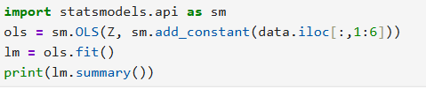
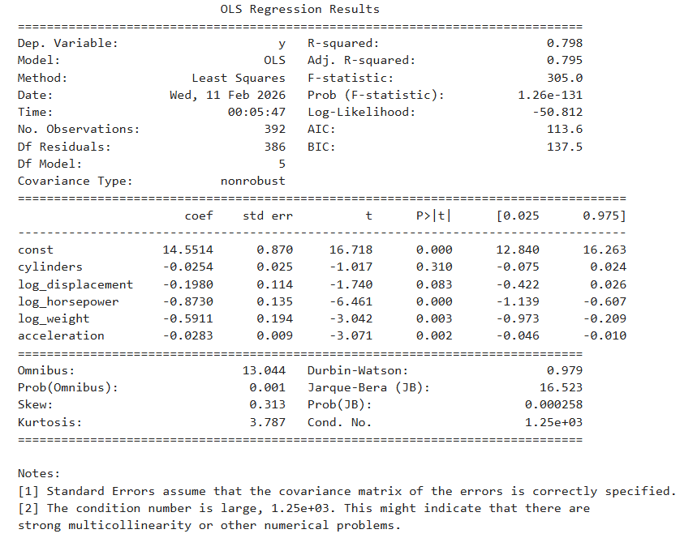
As the OLS results shown above, the model 5 fitted regression is:
Z (lambda mpg) = 14.5514 – 0.0254cylinders – 0.1980log_displacement – 0.8730log_horsepower – 0.5911log_weight – 0.0283acceleration
The R² result slightly increase from 0.708 to 0.798, indicating that the model regression explains the variation better.
Based on the results, the log_hoursepower, log_weight and acceleration predictors are all significant in explaining the response value mpg since their p-values are less than 0.05. However, the cylinders and log_displacement predictors are not significant in the variance explanation of the regressions because their p-value are greater than 0.05.
Step 5: Redo the diagnostic check
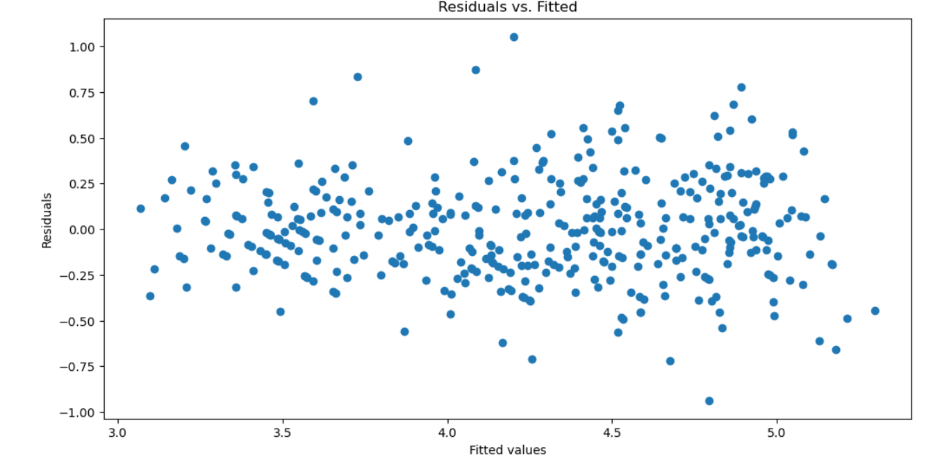
- In residual plot, the zero mean assumption is mostly satisfied since the data scatters randomly with even values for each side of 0. Thus, the constant variance assumption seems to be satisfied as fitted values increase, the variance of residuals stays constant.
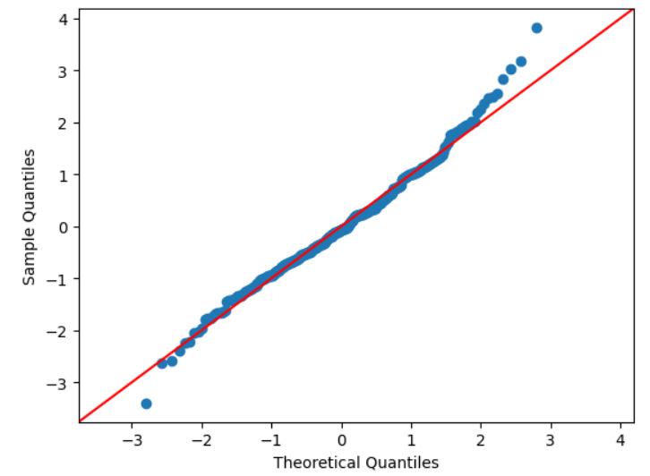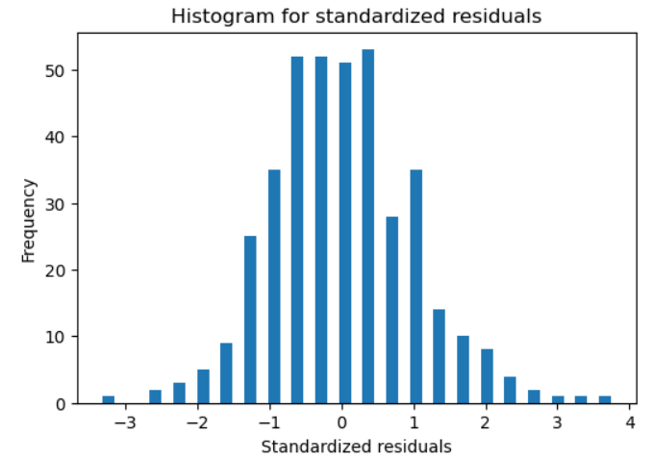
- The Q-Q plot shows that the residuals has some of the values are not close to the 45-degree reference line. Thus, the histogram shows the slightly right skewness compared to the previous models. Therefore, both of Q-Q plot and the histogram suggests there is still slight deviation at the tails, indicating a small violation of normality assumption after the Box-Cox transformation.

7. Please compare all the models that we have just constructed (model 1 – 5). Which is best model that you would like to report, and briefly explain why.
The following table is the comparison between all the models (model 1-5):
 | Model 1 | Model 2 | Model 3 | Model 4 | Model 5
R² | 0.760 | 0.748 | 0.791 | 0.805 | 0.798
Significant Predictors | Displacement1,2  Horsepower1,2  Acceleration | log_dsplacement  log_horsepower  log_weight  Acceleration | Horsepower  Weight | log_horsepower  log_weight  Acceleration | log_horsepower  log_weight  Acceleration
Zero Mean | Slightly violated | Slightly violated | Mostly satisfied | Mostly satisfied | Mostly satisfied
Constant Variance | Slightly violated | Slightly violated | Mostly satisfied | Mostly satisfied | Mostly satisfied
Normality | Violated (Right skewness) | Violated (Right skewness) | Approximately normal | Approximately normal | Slight violated (Right skewness)

The most model I would like to report is Model 4 as the following reasons:
First, Model 4 has the highest R² = 0.805, indicating that its regression model explains the most variance of response data (mpg) comparing to other models.
Second, Model 4 reasonably satisfies the assumptions of the linear regression. The residuals plot show that the residuals randomly scatter around zero, suggesting the zero mean assumption is satisfied. Moreover, as the fitted value increases, the variance of the residuals is approximately constant. Thus, the Q-Q plot and histogram both suggests the residuals are approximately normally distributed.
Third, the predictors of the model are statistically significant and interpretable.
Last, the Box-Cox transformation results λ = 0.19 in Model 5, which is close to 0, suggesting the log transformation is appropriate.
Therefore, Model 4 provides the best combination between assumption satisfaction, explanation of variability, and interpretability.

